**Program No.06**

**Program title** Ultra sonic sound sensor

**Aim**

To measure distance of object

**Hardware Required**

Arduino board

Temperature sensor (tmp36)

Buzzer

Led

**Circuit**

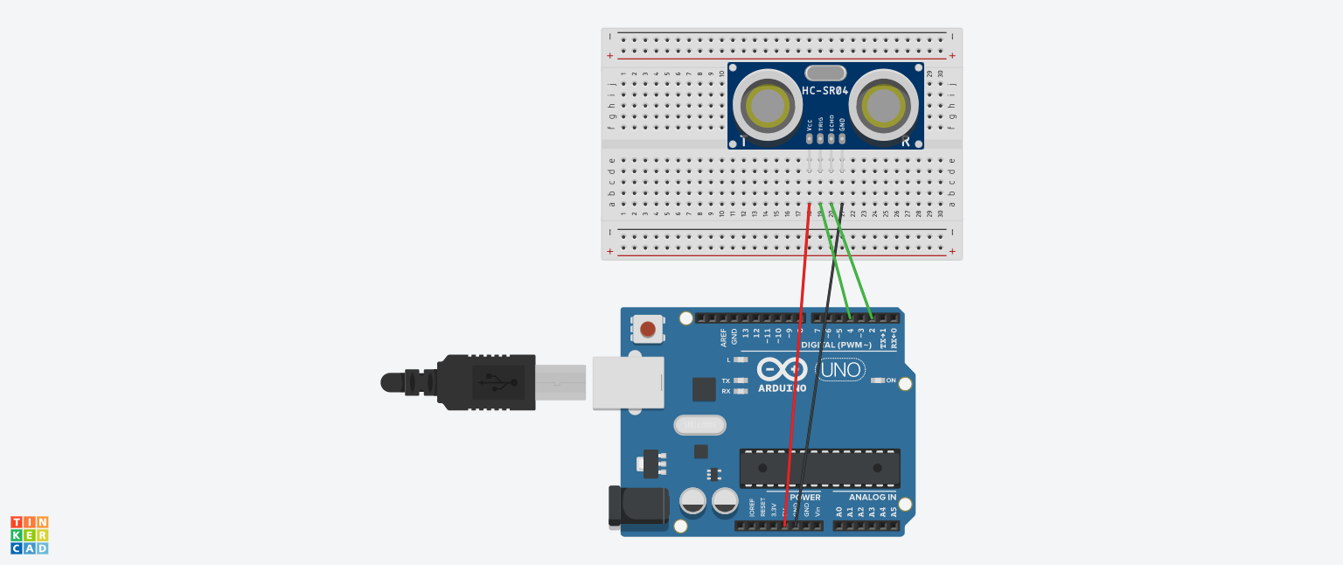

**Code**

#define echoPin 2

#define trigPin 4

long duration;

int distance;

void setup() {

pinMode(trigPin, OUTPUT);

pinMode(echoPin, INPUT);

Serial.begin(9600);

}

void loop() {

digitalWrite(trigPin, LOW);

delayMicroseconds(2);

digitalWrite(trigPin, HIGH);

delayMicroseconds(10);

digitalWrite(trigPin, LOW);

duration = pulseIn(echoPin, HIGH);

distance = duration * 0.034 / 2;

Serial.print("Distance: ");

Serial.print(distance);

Serial.println(" cm");

}